Que. 1) Create an html file with a submit button and a paragraph. Now modify the style of the paragraph text through JavaScript code.

Sample paragraph:

It is rightly said that being disciplined is essential in life. When a person leads a disciplined life, they set an easy path to success. They will develop an approach to happiness and a beautiful future ahead. Being disciplined is the practice of having a scheduled daily routine which helps an individual to be punctual and hard-working. An individual is taught what being disciplined means from the time they are young. Even though discipline takes a lot of effort, the advantages of a disciplined life make it a worthwhile endeavour.

Task: Clicking on the button, the font, font size, and colour of the paragraph text will be changed

<!DOCTYPE html>

<html lang="en">

<head>

    <meta charset="UTF-8">

    <meta name="viewport" content="width=device-width, initial-scale=1.0">

    <title>Paragraph Style Changer</title>

    <style>

        body {

            display: flex;

            justify-content: center;

            align-items: center;

            height: 100vh;

            background-color: #f0f8ff;

            text-align: center;

        }

        button {

            padding: 10px 20px;

            background-color: #4CAF50;

            color: white;

            font-size: 16px;

            border: none;

            border-radius: 5px;

            cursor: pointer;

        }

        p {

            max-width: 600px;

            margin-top: 20px;

            font-size: 18px;

            color: black;

        }

    </style>

</head>

<body background="C:\Users\rushi\OneDrive\Desktop\aaa.jpg">

    <div>

        <button onclick="changeParagraphStyle()">Change Style</button>

        <p id="myParagraph">

            It is rightly said that being disciplined is essential in life. When a person leads a disciplined life, they set an easy path to success. They will develop an approach to happiness and a beautiful future ahead. Being disciplined is the practice of having a scheduled daily routine which helps an individual to be punctual and hard-working. An individual is taught what being disciplined means from the time they are young. Even though discipline takes a lot of effort, the advantages of a disciplined life make it a worthwhile endeavour.

        </p>""

    </div>

    <script>

        function changeParagraphStyle() {

            const paragraph = document.getElementById("myParagraph");

            paragraph.style.fontFamily = "Arial, sans-serif";

            paragraph.style.fontSize = "20px";

            paragraph.style.color = "#ff4500";

        }

    </script>

</body>

</html>

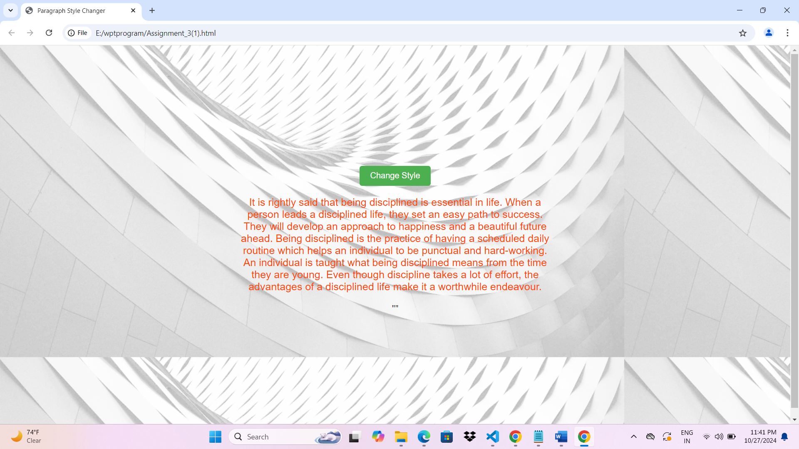

Que. 2) Create a form with First name, last name, contact no., email id. Write a JavaScript function to get the values from that particular form. When a submit button is clicked, form values should be printed on the browser page.<!DOCTYPE html>

<html lang="en">

<head>

    <meta charset="UTF-8">

    <meta name="viewport" content="width=device-width, initial-scale=1.0">

    <title>Form Submission</title>

    <style>

        body {

            display: flex;

            justify-content: center;

            align-items: center;

            height: 100vh;

            background-color: #e6e6fa;

        }

        form {

            background-color: #fff;

            padding: 20px;

            border-radius: 10px;

            box-shadow: 0px 0px 10px 0px rgba(0, 0, 0, 0.1);

            text-align: center;

        }

        label, input {

            display: block;

            margin: 5px;

            font-size: 18px;

        }

        button {

            margin-top: 10px;

            padding: 8px 16px;

            background-color: #1e90ff;

            color: white;

            border: none;

            border-radius: 5px;

            cursor: pointer;

        }

        .result {

            margin-top: 20px;

            font-size: 18px;

            color: #333;

        }

    </style>

</head>

<body background="C:\Users\rushi\OneDrive\Desktop\aaa.jpg">

    <form onsubmit="displayFormValues(event)">

        <label>First Name: <input type="text" id="firstName"></label>

        <label>Last Name: <input type="text" id="lastName"></label>

        <label>Contact No.: <input type="text" id="contactNo"></label>

        <label>Email ID: <input type="email" id="emailId"></label>

        <button type="submit">Submit</button>

    </form>

    <div class="result" id="formResult"></div>

    <script>

        function displayFormValues(event) {

            event.preventDefault();

            const firstName = document.getElementById("firstName").value;

            const lastName = document.getElementById("lastName").value;

            const contactNo = document.getElementById("contactNo").value;

            const emailId = document.getElementById("emailId").value;

            document.getElementById("formResult").innerHTML = `

                <p>First Name: ${firstName}</p>

                <p>Last Name: ${lastName}</p>

                <p>Contact No.: ${contactNo}</p>

                <p>Email ID: ${emailId}</p>

            `;

        }

    </script>

</body>

</html>

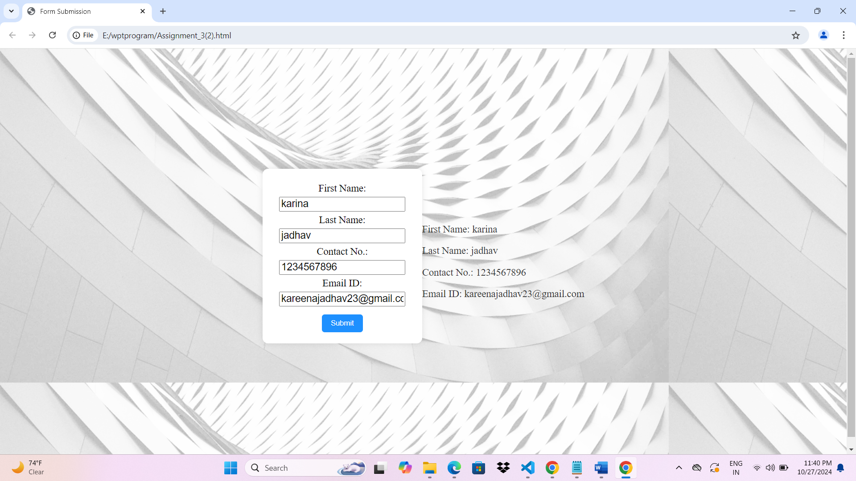

Que. 3) Write a JavaScript program to remove items from a drop-down list.

<!DOCTYPE html>

<html lang="en">

<head>

    <meta charset="UTF-8">

    <meta name="viewport" content="width=device-width, initial-scale=1.0">

    <title>Remove Items from Dropdown</title>

    <style>

        body {

            display: flex;

            justify-content: center;

            align-items: center;

            height: 100vh;

            background-color: #f5f5f5;

            text-align: center;

        }

        select, button {

            margin: 10px;

            padding: 8px 12px;

            font-size: 16px;

        }

        button {

            background-color: #ff6347;

            color: white;

            border: none;

            border-radius: 5px;

            cursor: pointer;

        }

    </style>

</head>

<body background="C:\Users\rushi\OneDrive\Desktop\aaa.jpg">

    <div>

        <select id="myDropdown">

            <option value="Item1">Item 1</option>

            <option value="Item2">Item 2</option>

            <option value="Item3">Item 3</option>

            <option value="Item4">Item 4</option>

        </select>

        <button onclick="removeSelectedItem()">Remove Selected Item</button>

    </div>

    <script>

        function removeSelectedItem() {

            const dropdown = document.getElementById("myDropdown");

            dropdown.remove(dropdown.selectedIndex);

        }

    </script>

</body>

</html>

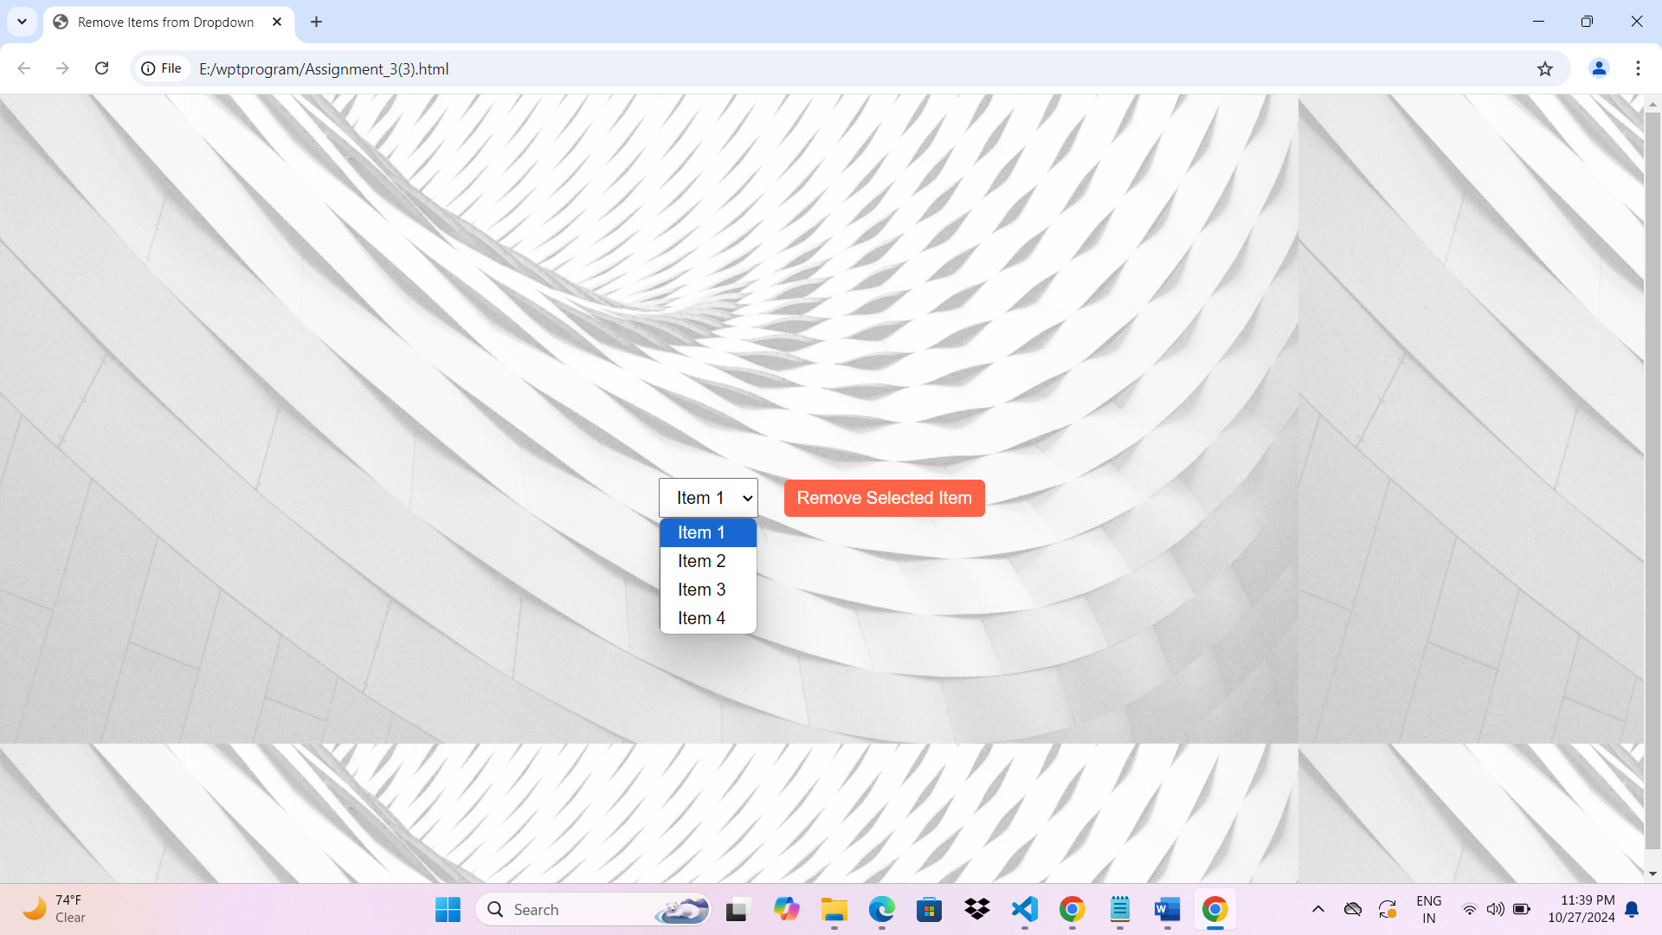

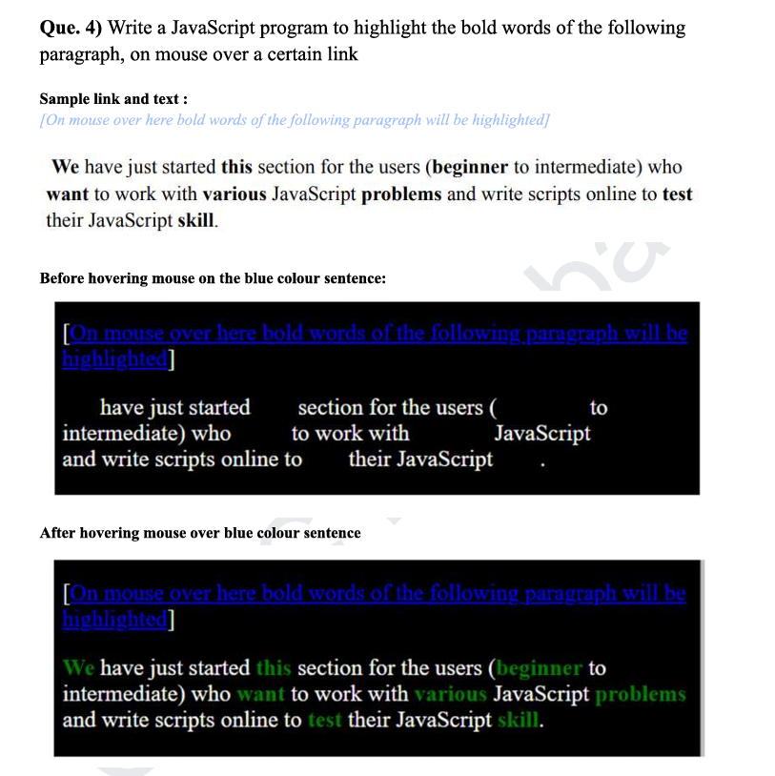

<!DOCTYPE html>

<html lang="en">

<head>

    <meta charset="UTF-8">

    <meta name="viewport" content="width=device-width, initial-scale=1.0">

    <title>Highlight Bold Words</title>

    <style>

        /\* Initial styles for bold words \*/

        b {

            color: black;

        }

    </style>

<body background="C:\Users\rushi\OneDrive\Desktop\aaa.jpg">

    <!-- Link to trigger the highlighting -->

    <p>

        <a href="#" onmouseover="highlightBoldWords()" onmouseout="resetBoldWords()" style="color: blue; text-decoration: underline;">

            On mouse over here bold words of the following paragraph will be highlighted

        </a>

    </p>

    <!-- Sample paragraph with bold words -->

    <p id="paragraph">

        We <b>have</b> just started this <b>section</b> for the <b>users</b> (beginner to <b>intermediate</b>) who want to <b>work</b> with various JavaScript <b>problems</b> and <b>write</b> scripts online to <b>test</b> their JavaScript <b>skill</b>.

    </p>

    <script>

        function highlightBoldWords() {

            // Get all bold elements in the paragraph

            const boldWords = document.querySelectorAll("#paragraph b");

            // Change color of bold words to highlight them

            boldWords.forEach(word => {

                word.style.color = "red";

                word.style.fontWeight = "bold";

            });

        }

        function resetBoldWords() {

            // Reset color of bold words to original style

            const boldWords = document.querySelectorAll("#paragraph b");

            boldWords.forEach(word => {

                word.style.color = "black";

                word.style.fontWeight = "normal";

            });

        }

    </script>

</body>

</html>

